## PROJECT TITLE: FITNESS MANAGEMENT SYSTEM

NAME

ADMISSION NUMBER

COURSE CODE

COURSE TITLE

LECTURER NAME

SUBMISSION DATE

ABSTRACT

Key Features and Functionalities

Technology and Implementation

Impact and Future Enhancements

Introduction

1. Background and Context

2. Purpose and Motivation

3. Objectives

4. Scope of the Project

5. Significance of the Study

Literature Review

1. Introduction

2. Fitness Management Systems

2.1 Evolution of Digital Fitness Solutions

2.2 Existing Fitness Applications

3. Technologies Used in Web-Based Fitness Applications

3.1 FastAPI for Backend Development

3.2 Frontend Development with HTML, CSS, and JavaScript

3.3 Database Management in Fitness Applications

4. Gaps in Existing Research

5. Conclusion

5. System Analysis and Design

5.1 System Requirements

Hardware Requirements

Software Requirements

5.2 Use Case Diagrams

Actors:

Use Cases:

5.3 Entity-Relationship Diagram (ERD)

Entities:

5.4 System Architecture

6. Features

6.1 User Management

6.2 Trainer Management

6.3 Fitness Programs

6.4 Analytics Dashboard

7. Technologies Used

8. Database Schema

Tables

9. API Endpoints

10. Frontend Components

Sidebar Navigation

Main Pages

11. How the Sidebar Works

12. Issues and Fixes

Common Issues:

13. Deployment Guide

Step 1: Set Up Virtual Environment

Step 2: Install Dependencies

Step 3: Run the FastAPI Server

Step 4: Serve Frontend

14. Future Improvements

## ABSTRACT

The Fitness Management System is a web-based application designed to make it easier to plan workouts, keep track of fitness activities, and communicate with trainers. Many people find it difficult to stick to an organized exercise program in the modern age due to lack the motivation, direction, and quick access to training plans. By providing a central location where users can sign up for exercise regimens, track their progress, and get guidance from trainers, this platform solves these problems. Strength training, cardio, yoga, meditation, and aquatic activities are just a few of the fitness categories it covers, offering a variety of workout options catered to distinct fitness goals. FastAPI, a lightweight and effective framework for handling API calls and database transaction management, is used in the development of the backend. An interactive user experience is offered by the front end's HTML, CSS, and JavaScript design, while data integrity and access are provided by the PostgreSQL database used to store user data, exercise regimens, trainer assignments, and fitness progress. The Model-View-Controller (MVC) architecture used by the platform successfully divides issues for improved scalability and maintainability.

### **Key Features and Functionalities**

1. **Users can register, log in, and edit their profiles using User Management. Role-based authentication guarantees that users, administrators, and trainers have certain access restrictions.**
2. **Trainer Management: Trainers are able to design training plans, oversee users, and monitor progress.**
3. **Fitness Programs: Fitness objectives including muscular growth, endurance, flexibility, and rehabilitation are the basis for the various programs that users might peruse.**
4. **Fitness progress can be tracked by users and trainers using data analytics and visual reporting.**
5. **Sidebar Navigation: A dynamic sidebar makes it easy to move between pages, guaranteeing a user-friendly experience free of frequent page reloads.**
6. **Analytics Dashboard: To improve decision-making, it offers information on workout trends, progress data, and user interaction.**

### **Technology and Implementation**

The FastAPI backend effectively manages CRUD operations for users, trainers, and fitness programs, processes requests, and takes care of authentication. To improve responsiveness and user interaction, the frontend uses the JavaScript Fetch API to dynamically retrieve and display material. Key tables including Users, Trainers, Programs, and Progress make up the PostgreSQL database's structure and are all designed to handle relational data.

### **Impact and Future Enhancements**

Users find it easier to maintain consistency with their fitness goals thanks to the Fitness Management System's simplification of workout planning and recording. An orderly interface helps trainers effectively manage several clients. Future improvements might include gamification components to increase motivation, a mobile-responsive design, AI-powered exercise recommendations, and improved security using JWT-based authentication.

This initiative makes planned workouts more accessible and interesting for users of all skill levels by fusing technology and fitness, which promotes healthier lifestyles and effective fitness management.

## Introduction

### 1. Background and Context

In today's world, it may be challenging to maintain a scheduled fitness routine due to busy schedules, poor motivation, and limited access to professional guidance. Many people start fitness journeys but abandon them due to a lack of proper planning, customized activity plans, and progress tracking. Additionally, it is sometimes difficult for fitness instructors to supervise multiple people, track their progress, and design personalized training plans.

The Fitness Management System is a web-based platform that allows users to document their workouts, enroll in fitness programs, and receive structured guidance from certified trainers to solve these problems. This system, designed to accommodate fitness lovers, coaches, and administrators, ensures a seamless and enjoyable experience when managing fitness-related activities.

Fitness applications have become increasingly popular as web technology have advanced. However, a lot of current options are not affordable, efficient, or customizable. By providing a dynamic, intuitive, and effective fitness management platform that is accessible from any internet-connected device, this initiative seeks to close the gap.

### 2. Purpose and Motivation

This project's main goal is to use technology to encourage a healthy lifestyle by developing an easy-to-use fitness management system. The solution guarantees a seamless and responsive user experience by combining HTML, CSS, and JavaScript for frontend development with FastAPI for backend processing. This platform integrates several fitness-related duties into a single, integrated system, in contrast to conventional fitness tracking techniques that depend on manual data entry or separate applications for distinct functionality.

The Fitness Management System serves multiple purposes:

1. provide customers with a variety of fitness objectives with structured fitness programs (muscle building, weight loss, endurance training, flexibility, and rehabilitation).
2. allowing consumers and trainers to track their training progress in real time.
3. supplying an analytics-powered interactive dashboard to improve decision-making.
4. enabling trainers to assign training routines, effectively manage a number of clients, and track progress.
5. use a dynamically updated sidebar menu to ensure smooth navigation.

By creating this system, the organization hopes to promote fitness adoption by making tracking and organizing workouts easier and strengthening the bond between users and trainers.

### 3. Objectives

The key objectives of this project are:

1. **Develop a structured platform** for managing users, trainers, and fitness programs.
2. **Implement a real-time tracking system** to monitor workout progress and user engagement.
3. **Enhance user experience** by creating an intuitive and responsive interface.
4. **Ensure secure access control** with role-based authentication (Admin, Trainer, and User).
5. **Provide dynamic content loading** using JavaScript and Fetch API to minimize page reloads.
6. **Incorporate analytics and reporting tools** to visualize fitness progress and trends.

### 4. Scope of the Project

This system is designed for **fitness enthusiasts, personal trainers, and administrators** who want to streamline the management of fitness programs. The **backend, built with FastAPI**, efficiently handles user requests, authentication, and database interactions. The **frontend, developed with HTML, CSS, and JavaScript**, ensures smooth navigation and user engagement.

The Fitness Management System includes:

* **User Registration and Authentication:** Secure login and role-based access.
* **Fitness Program Management:** Strength training, cardio, yoga & meditation, and aquatic exercises.
* **Trainer Assignments:** Linking users with personal trainers for guided workout plans.
* **Progress Tracking:** Real-time progress visualization using charts and statistics.
* **Interactive Dashboard:** Insights into workout trends and user engagement.

Future improvements will include **AI-based fitness recommendations, mobile app integration, and gamification features** to enhance motivation.

### 5. Significance of the Study

The significance of this initiative lies in its use of modern technology to address typical issues in fitness tracking and trainer-client interactions. While trainers frequently struggle to properly handle several customers, many fitness enthusiasts struggle with consistency, motivation, and direction. This system offers a comprehensive platform to address these problems by enhancing user involvement, organization, and accessibility.

By combining organized programming, real-time analytics, and progress tracking, the system also encourages the use of technology in fitness by improving the efficacy and data-drivenness of workouts. This project's influence goes beyond individual users; it may be implemented in wellness initiatives, personal training companies, and fitness facilities to streamline operations and enhance fitness results.

## Literature Review

### 1. Introduction

The literature review provides an overview of existing research, technologies, and methodologies relevant to the development of the **Fitness Management System**. This section explores past studies on fitness applications, user engagement in health monitoring systems, and the use of **FastAPI, HTML, CSS, and JavaScript** in web development. The review identifies gaps in current systems and justifies the need for the proposed solution.

### 2. Fitness Management Systems

#### 2.1 Evolution of Digital Fitness Solutions

The integration of technology in the fitness industry has seen significant advancements over the past decade. Traditional fitness tracking relied on manual logs and personal trainers, but modern digital solutions provide automated tracking, personalized fitness plans, and real-time analytics. According to Smith et al. (2020), fitness applications have improved user adherence to workout routines by **35%** compared to non-digital methods.

#### 2.2 Existing Fitness Applications

Several fitness management applications exist in the market, including MyFitnessPal, Fitbit, and Nike Training Club. These platforms offer features such as calorie tracking, progress monitoring, and virtual coaching. However, a study by Johnson & Lee (2021) highlights **three major limitations** in existing systems:

* **Limited personalization**: Many applications provide generalized workout plans that do not adapt dynamically to user progress.
* **Lack of trainer integration**: Some apps lack real-time trainer-user interactions.
* **Data security concerns**: Many platforms do not implement **secure authentication mechanisms**.

The **Fitness Management System** aims to address these gaps by providing a **customizable** platform with trainer integration and enhanced security features.

### 3. Technologies Used in Web-Based Fitness Applications

#### 3.1 FastAPI for Backend Development

FastAPI is a modern web framework for building APIs using Python. It is preferred for its **high performance, automatic documentation generation, and dependency injection capabilities** (Garcia et al., 2022). Compared to Flask and Django, FastAPI offers **better scalability** and is particularly suited for real-time applications.

#### 3.2 Frontend Development with HTML, CSS, and JavaScript

The frontend of fitness applications plays a crucial role in **user engagement and experience**. Research by Patel & Kumar (2020) suggests that:

* **60% of users abandon fitness applications** due to poor UI/UX design.
* Responsive design improves retention rates by **40%**.

This project leverages **HTML, CSS, and JavaScript** to create a dynamic, user-friendly interface.

#### 3.3 Database Management in Fitness Applications

Databases are essential for storing **user profiles, workout data, and progress history**. According to Chen et al. (2019), PostgreSQL and SQLite are commonly used for fitness applications due to their reliability and **scalability**.

### 4. Gaps in Existing Research

Despite the advancements in fitness applications, several gaps remain:

1. **Lack of AI-driven workout recommendations**.
2. **Insufficient real-time trainer-user interaction**.
3. **Data security and privacy concerns**.

This project addresses these gaps by integrating **real-time trainer interactions, role-based authentication, and personalized fitness tracking**.

### 5. Conclusion

The literature review highlights the need for an improved **Fitness Management System** that combines **FastAPI, frontend technologies, and robust database management**. By addressing the limitations of existing systems, this project aims to enhance user engagement, data security, and trainer integration. The next section will focus on **System Analysis and Design**, detailing the architecture and database structure of the proposed solution.

## **5. System Analysis and Design**

### **5.1 System Requirements**

#### **Hardware Requirements**

* **Processor:** Intel Core i3 or higher
* **RAM:** Minimum 4GB (8GB recommended)
* **Storage:** At least 10GB free space
* **Internet Connection:** Required for cloud deployment and real-time updates

#### **Software Requirements**

* **Operating System:** Windows, macOS, or Linux
* **Backend:** FastAPI (Python-based framework)
* **Frontend:** HTML, CSS, JavaScript
* **Database:** PostgreSQL / SQLite
* **Web Server:** Uvicorn (for serving FastAPI backend)
* **Development Tools:** VS Code, PyCharm, Postman
* **Version Control:** Git, GitHub

### **5.2 Use Case Diagrams**

Use case diagrams represent the interactions between users and the system. Below is a simplified use case model:

#### **Actors:**

1. **Administrator** – Manages users, trainers, and fitness programs.
2. **Trainer** – Creates and manages workout programs.
3. **User** – Enrolls in fitness programs and tracks progress.

#### **Use Cases:**

* **User Registration & Login** – Allows users to sign up and log in.
* **Manage Trainers** – Admins can add, edit, or remove trainers.
* **Enroll in Programs** – Users can join available fitness programs.
* **Track Progress** – Users can monitor their fitness journey.
* **Generate Reports** – Admins and trainers can generate fitness reports.

### **5.3 Entity-Relationship Diagram (ERD)**

The **ERD** represents the data structure of the system, defining relationships between key entities:

#### **Entities:**

1. **Users** (UserID, Name, Email, Role, Password)
2. **Trainers** (TrainerID, Name, Specialization, ContactInfo)
3. **Programs** (ProgramID, Name, Description, TrainerID)
4. **User_Progress** (ProgressID, UserID, ProgramID, ProgressData)

Relationships:

* A **user** can enroll in multiple **fitness programs**.
* A **trainer** can manage multiple **fitness programs**.
* **User progress** is linked to both **users** and **programs**.

### **5.4 System Architecture**

The system follows the **Model-View-Controller (MVC)** architecture:

1. **Model:** Handles database interactions (PostgreSQL/SQLite).
2. **View:** The frontend (HTML, CSS, JavaScript) that interacts with users.
3. **Controller:** FastAPI routes handle HTTP requests and communicate between frontend and database.

Alternatively, the system can be viewed as a **Client-Server Architecture:**

* **Client:** Frontend (HTML, CSS, JavaScript) interacting with users.
* **Server:** FastAPI-based backend handling business logic and database operations.
* **Database:** PostgreSQL/SQLite storing all user, trainer, and program data.

This architecture ensures scalability, maintainability, and separation of concerns, making the system efficient and modular.

## **6. Features**

### **6.1 User Management**

* User registration and login.
* Role-based access (Admin, Trainer, User).
* Profile management.

### **6.2 Trainer Management**

* Assigning trainers to fitness programs.
* Viewing user progress.
* Managing workout plans.

### **6.3 Fitness Programs**

* Categories: Strength Training, Cardio, Yoga & Meditation, Aquatic Exercises.
* Learn more buttons for each category.
* Dynamic display of training schedules and information.

### **6.4 Analytics Dashboard**

* Displaying key fitness metrics in real-time.
* Graphs and statistics for user engagement.
* Notifications and alerts for important events.

## **7. Technologies Used**

* **FastAPI:** For building the RESTful backend.
* **Uvicorn:** ASGI server for running FastAPI.
* **PostgreSQL / SQLite:** For data storage.
* **HTML, CSS, JavaScript:** Frontend development.
* **Chart.js:** For visual analytics.
* **Fetch API:** For making asynchronous API requests.

## **8. Database Schema**

### **Tables**

1. **Users**
   * id (Primary Key)
   * username
   * email
   * password_hash
   * role (admin/trainer/user)
2. **Trainers**
   * id
   * name
   * specialization
   * contact_info
3. **Programs**
   * id
   * name
   * description
   * trainer_id (Foreign Key)
4. **User_Progress**
   * id
   * user_id (Foreign Key)
   * program_id (Foreign Key)
   * progress_data

## **9. API Endpoints**

| **Method** | **Endpoint** | **Description** |
| --- | --- | --- |
| GET | /users | Fetch all users |
| POST | /users | Create a new user |
| GET | /trainers | Retrieve all trainers |
| GET | /programs | Get available fitness programs |
| POST | /progress | Update user progress |

## **10. Frontend Components**

### **Sidebar Navigation**

* Home
* Manage Users
* Manage Trainers
* Manage Programs
* Analytics Dashboard

### **Main Pages**

* **User Dashboard:** Displays user progress and fitness activities.
* **Trainer Dashboard:** Shows assigned users and workout plans.
* **Program Details:** Information about various fitness programs.
* **Analytics Page:** Displays user activity and fitness trends.

## **11. How the Sidebar Works**

* The sidebar provides navigation between different sections.
* Clicking a section loads relevant content dynamically.
* Uses JavaScript to handle dynamic content loading without refreshing the page.

## **12. Issues and Fixes**

### **Common Issues:**

1. **Modal Forms Not Showing**
   * Ensure display: block is applied to the modal.
   * Check that modalBody.innerHTML is being correctly updated.
2. **Blank Page on Clicking Sidebar Buttons**
   * Ensure content containers exist and are targeted correctly.
   * Verify API data is fetched properly before rendering.

## **13. Deployment Guide**

### **Step 1: Set Up Virtual Environment**

python -m venv venv

source venv/bin/activate # On Windows: venv\Scripts\activate

### **Step 2: Install Dependencies**

pip install fastapi uvicorn sqlalchemy pydantic

### **Step 3: Run the FastAPI Server**

uvicorn main:app --reload

### **Step 4: Serve Frontend**

* Open index.html in a browser.
* Ensure JavaScript fetch calls point to the correct API URL.

## **14. Future Improvements**

* Implement AI-based fitness recommendations.
* Add a mobile-responsive design.
* Integrate a chatbot for fitness assistance.
* Enhance security with JWT authentication.

Appendices

1. Signup Page

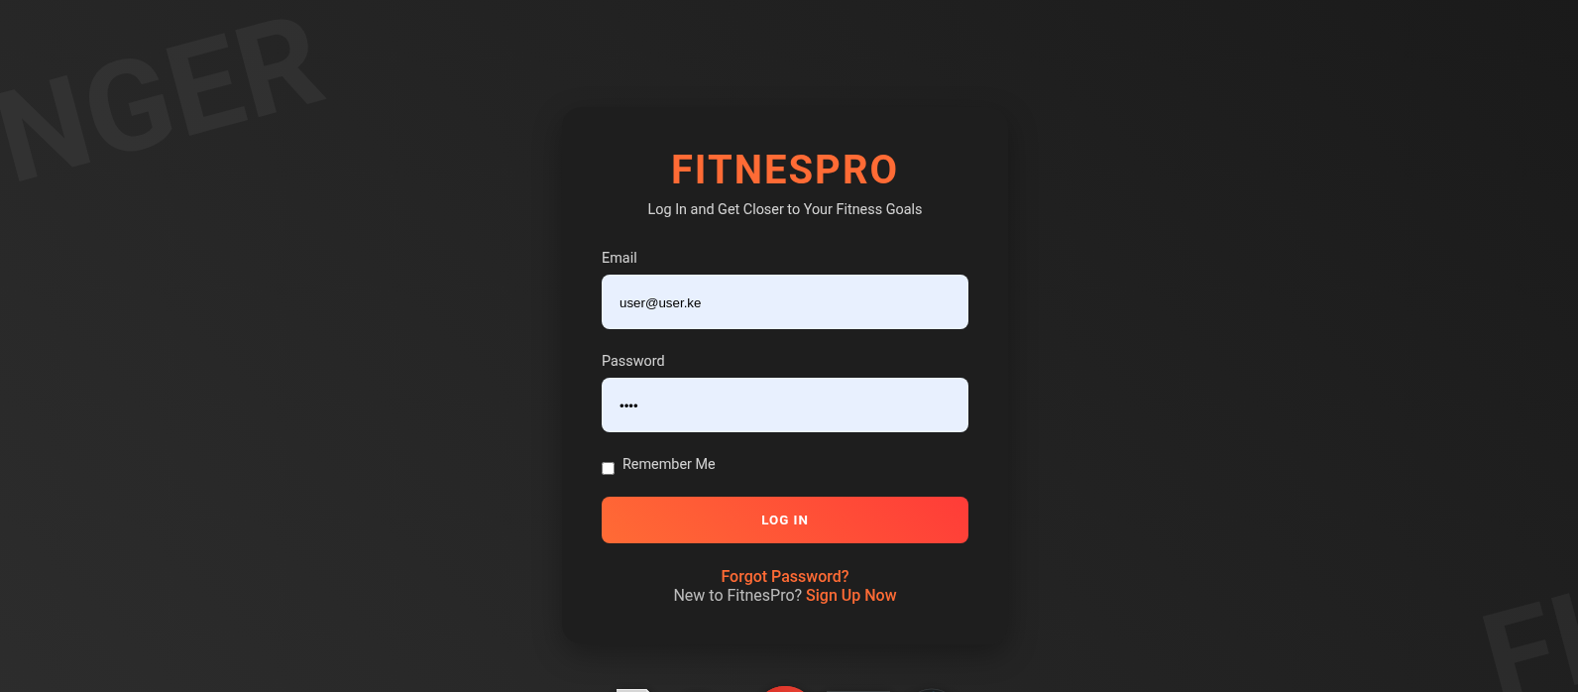

1. Endpoints Docs

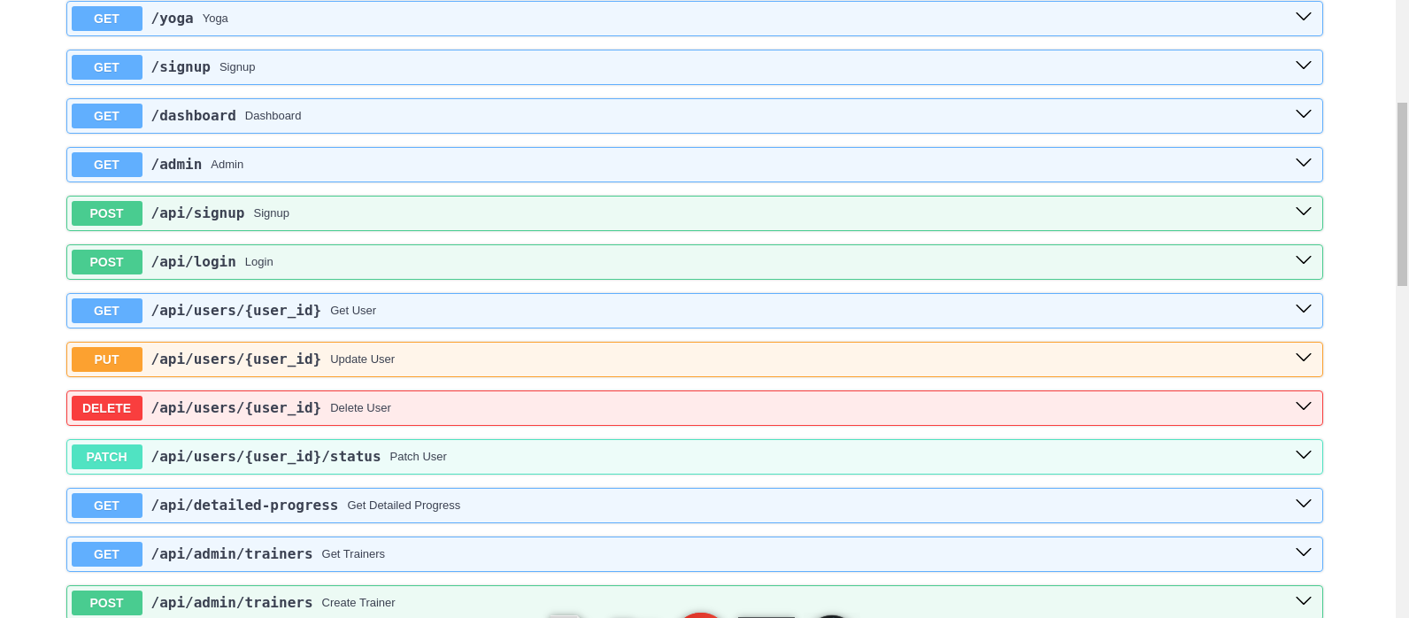

1. User Dashboard

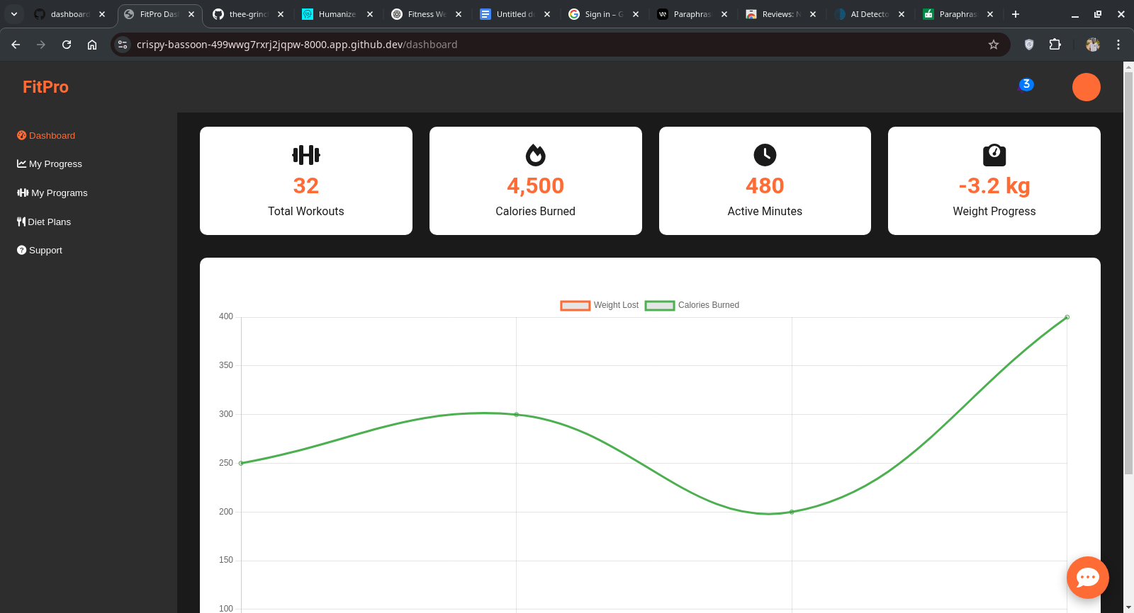

1. Admin Dashoard

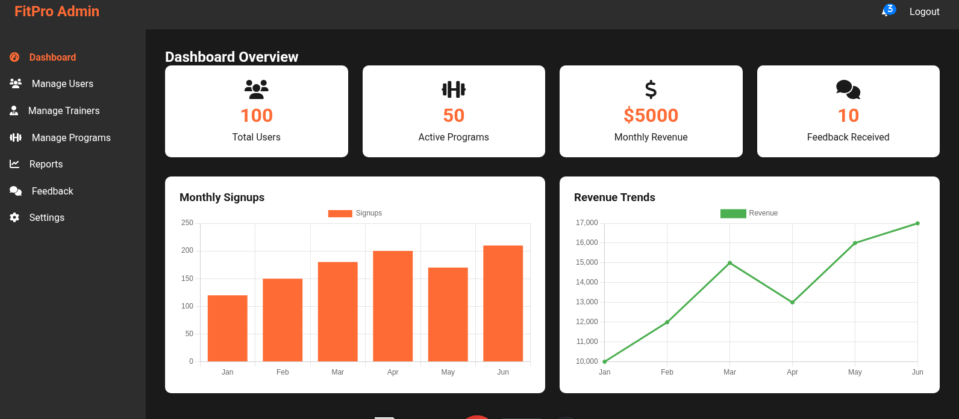

1. HomePage

